Several decades of sprites ?

Are sprites still in use?

Krzysiek D.
What is SPRITE?

- Small 2D object

- It can be moved, scaled, and animated independently of the background or other objects

- Sprites are supported by specialized hardware features in many graphics systems, which allow for efficient rendering and manipulation

First video game (not computer game)
TENNIS FOR TWO (1958)
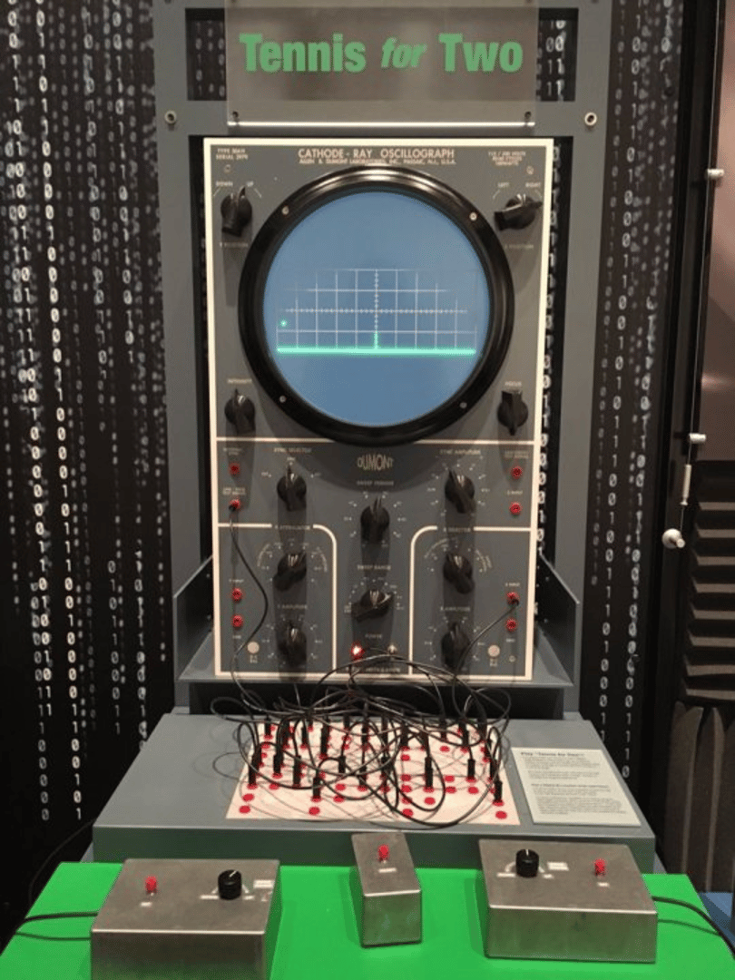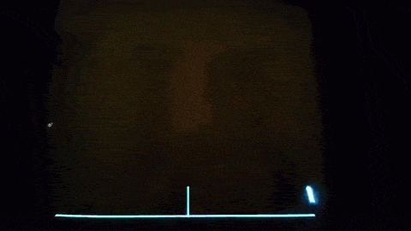
Second video game: Spacewar! (MIT 1962)
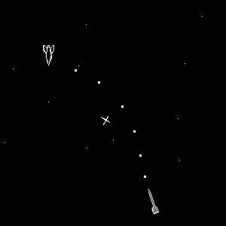

Pong (Atari 1972) – first commercial game
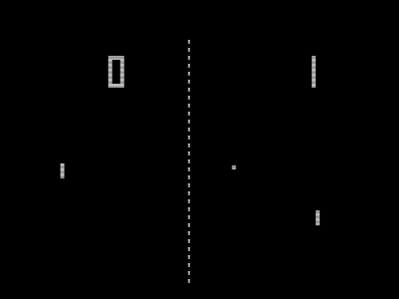

Atari company (1972 – 1992)
Atari 800XL (1981)

8-bit microprocessor MOS 6502:
Registers: Accumulator, X, Y
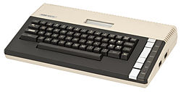
Player/Missile Graphics:
- up to 4 players
- Multiple missiles
- Special graphics mode is required (eg. GRAPHICS 8)

10 GRAPHICS 8
20 POKE 559,62 :REM SDMCTL Direct Memory Access (DMA) enable
30 POKE 53248,20 :REM 53248 HPOSP0 (W) Horizontal position of player 0
40 WHT=15
50 POKE 704,WHT :REM Locations 704 to 712 ($2C0 to $2C8) are the color registers for players, missiles,and playfields
60 I=PEEK(106)-8 :REM RAMTOP - RAM size, defined by powerup
70 POKE 54279,I :REM CONSOL (W/R) Used to see if one of the three yellow console buttons has been pressed (not the RESET button!).
80 POKE 53277,3 :REM GRACTL (W) Used to turn on players and to turn on missiles.
90 POKE 53256,3 :REM SIZEP0 (W) Size of player 0.
100 REM DRAW 10 LINES (BACKGROUND)
110 FOR A = 70 TO 100 STEP 3
120 COLOR 1: PLOT 100,A: DRAWTO 315,A+20
130 NEXT A
200 J=I*256+1024
210 FOR Y=J+120 TO J+137
220 READ Z
230 POKE Y,Z
240 NEXT Y
250 FOR X=221 TO 48 STEP -1:GOSUB 500:NEXT X
260 GOTO 250
320 POKE Y,Z
500 POKE 53248,X :REM 53248 HPOSP0 (W) Horizontal position of player 0
510 RETURN
600 DATA 128,64,44,18,18,18
610 DATA 127,129,60,195,153,195
620 DATA 60,0,0,0,0,0

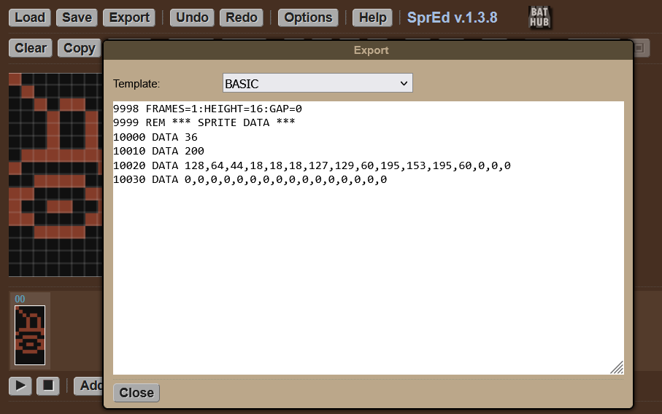Commodore company (1976 - 1994)
Commodore 64 (1982)

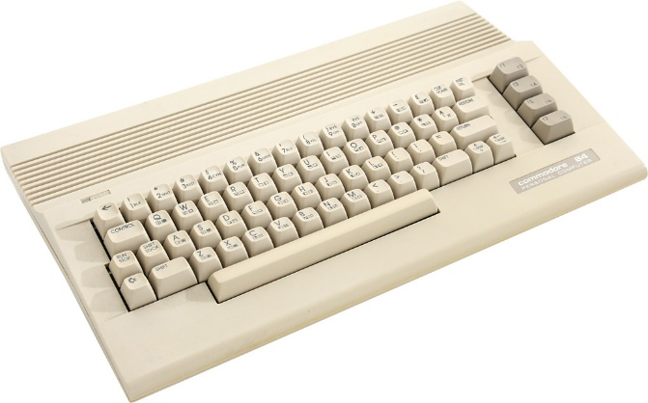
8-bit microprocessor MOS 6510:
Registers: Accumulator, X, Y
- 8 hardware sprites
- Sprites are independent on graphical/text mode
- Sprites created and controlled by specific RAM cells
- Total RAM 64 KB = 65535 B
- 53248($d000) S0 position X
- 53249($d001) S1 position Y
- 53248-53263($d000-$d00f) – positions X, Y of all sprites
- 53269($d015) – sprites enable
- 53287 – 53294($d027-$d02e) – sprite colors
- 2040-2047($07f8-$07ff) – sprite pointers
- 53278-53279($d027-$d028) - sprite collisions
- Memory map: https://sta.c64.org/cbm64mem.html

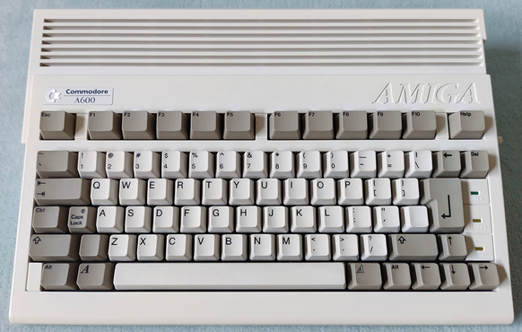
Amiga
16-bit processor registers

Hardware sprites:
- 8 sprite channels
(DMA Agnus + video chip
Denise)
- 16 pixels wide
- Any height
- 2 bits per pixel (3 colors + transparent)

Bobs:
- Software sprites
- Limited only by RAM amount

IBM company (since 1911)
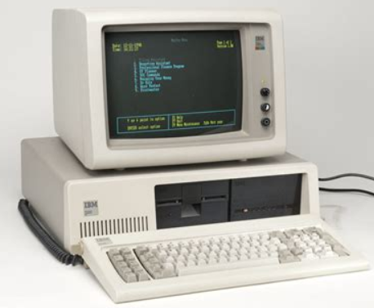
IBM PC + DOS (1981)
- 16-bit processor registers:
AX BX CX DX

- No sprites!!!

- Game animations – mani-
pulating with background
pixels

- Graphics modes 13h, CGA, EGA, VGA

Borland company (1983-2015)

Borland C++ 3 for DOS
- Graphics display supported by BGI (Borland Graphical Interface)

- Instead of sprites, a graphical object is simply drawn atop its background
Guido van Rossum (born 1956)
Python (1991)

- Named after British comic group Monty Python
- Main purpose?
- Initially no sprites
Library ARCADE (2014)
- Python supports OOP -> Sprite is a class

monster = arcade.Sprite("monster.bmp",scale=2,)
skull = arcade.Sprite("skull.bmp”)
enemy_list = arcade.SpriteList()
enemy_list.append(monster)
enemy_list.append(skull)
enemy_list.draw()

tankSprite = arcade.Sprite(tank.bmp")
tankSprite.center_x = 50
tankSprite.center_y = 350

Sun Microsystems (1982-2010)

Java (1995)
- Strongly OOP language
- Main purpose: enterprise programming (backend)
- "Java is like a wheel. Invented long time ago, but still needed"

- Initially – no sprites

GDX library (2014)

- GDX contains Sprite class
- Number of sprites limited only by RAM assigned to JVM

var batch = new SpriteBatch();
batch.begin();
batch.end();

var texture = new Texture(Gdx.files.internal(“tank.bmp”));
var sprite = new Sprite(texture);
sprite.setPosition(100, 40);

Netscape company (1994 – 2008)
JavaScript (1995)
- LiveScript – initial name
- language for web browsers (addition to static HTML)
- totally different than Java

Phaser library (2013)
- sprites (non-hardware)
- number of sprites limited only by RAM assigned for browser

Sprite manipulation : C64 vs Java vs JS

  - Position/Movement
Commodore | Java GDX | JS Phaser
Cells :  Cells $D002 - $D010 – remaining 7 sprites | sprite.setPosition(100,200); | sprite.y = 200 ;
  $D000  53248 | Sprite #0  X-coordinate (only bits #0-#7).
  $D001  53249 | Sprite #0  Y-coordinate.

  - Scaling
Commodore | Java GDX | JS Phaser
Cells : | sprite.setScale(10,3); | sprite.scaleX = 7 ;
  $D017  53271 | Sprite double height/width register. Bits: Bit #x: 1 = Sprite #x is stretched to double width.
  $D01D
  53277

3. Flipping
Commodore | Java GDX | JS Phaser
Not implemented. Workaround needed. | sprite.setFlip(false, true); | sprite.setFlipY(true)

4. Sprites collision
Commodore | Java GDX | JS Phaser
Cell $d019 (53273) bit #2 | float x1 = sprite0.getX();  float y1 = sprite0.getY();  float x2 = sprite1.getX();  float y2 = sprite1.getY();  float distance = MathUtils.sqrt(MathUtils.pow(x2 - x1, 2) + MathUtils.pow(y2 - y1, 2)); | Phaser.Math.Distance.Between(sprite1.x, sprite1.y, sprite2.x, sprite2.y)

Summary
- 7 environments were analyzed, regarding sprite support
(Atari 800, C64, Amiga, PC DOS C, Python, Java, JavaScript)

- Sprites still exist in programming languages

Other modern languages supporting sprites:
C# (Unity, MonoGame)
Swift (SpriteKit)
Rust (Bevy, ggez),
Lua (Love2D)

- Sprites are no more hardware-based

- Games went 3D, making 2D sprites not that crucial in game development
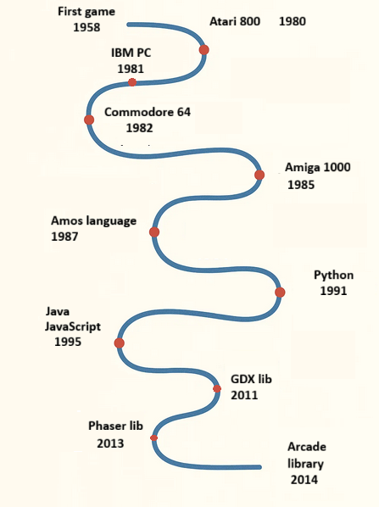
First game 1958
Atari 800 1980
IBM PC 1981
Commodore 64 1982
Amiga 1000 1985
language Amos 1987
Python 1991
library Arcade 2014
Java 1995
library GDX 2011
JavaScript 1995
library Phaser 2013

